Packet Tracer – Examining a Redundant Design

1. Topology

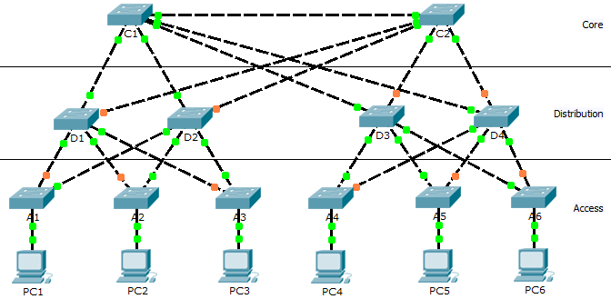

1. Objectives

Part 1: Check for STP Convergence

Part 2: Examine the ARP Process

Part 3: Test Redundancy in a Switched Network

1. Background

In this activity, you will observe how STP operates, by default, and how it reacts when faults occur. Switches have been added to the network “out of the box”. Cisco switches can be connected to a network without any additional action required by the network administrator. For the purpose of this activity, the bridge priority was modified.

1. Check for STP Convergence

When STP is fully converged, the following conditions exist:

* All PCs have green link lights on the switched ports.
* Access layer switches have one forwarding uplink (green link) to a distribution layer switch and a blocking uplink (amber link) to a second distribution layer switch.
* Distribution layer switches have one forwarding uplink (green link) to a core layer switch and a blocking uplink (amber link) to another core layer switch.

1. Examine the ARP Process
   1. Switch to Simulation mode.
   2. Ping from PC1 to PC6.
      1. Use the **Add Simple PDU** tool to create a PDU from **PC1** to **PC6**. Verify that ARP and ICMP are selected in the **Event List Filters**. Click **Capture/Forward** to examine the ARP process as the switched network learns the MAC addresses of **PC1** and **PC6**. Notice that all possible loops are stopped by blocking ports. For example, the ARP request from **PC1** travels from **A1** to **D2** to **C1** to **D1** and then back to **A1**. However, because STP is blocking the link between **A1** and **D1**, no loop occurs.
      2. Notice that the ARP reply from **PC6** travels back along one path. Why?

**Because the switches now know which path they need to go to get to PC1**

* + 1. Record the loop-free path between **PC1** and **PC6**. **PC1→ A1→ D2→ C1→ D3→ A6→ PC6**
  1. Examine the ARP process again.
     1. Below the **Scenario 0** drop-down list, click **New** to create **Scenario 1**. Examine the ARP process again by pinging between two different PCs.
     2. What part of the path changed from the last set of pings? **The access Switches are different.**

1. Test Redundancy in a Switched Network
   1. Delete the link between A1 and D2.

Switch to **Realtime** mode. Delete the link between **A1** and **D2**. It takes some time for STP to converge and establish a new, loop-free path. Because only **A1** is affected, watch for the amber light on the link between **A1** and **D1** to change to green. You can click **Fast Forward Time** to accelerate the STP convergence process.

* 1. Ping between PC1 and PC6.
     1. After the link between **A1** and **D1** is active (indicated by a green light), switch to **Simulation** mode and create **Scenario 2**. Ping between **PC1** and **PC6** again.
     2. Record the new loop-free path. **PC1→ A1→ D1→ C1→ D3→ A6→ PC6**
  2. Delete link between C1 and D3.
     1. Switch to **Realtime** mode. Notice that the links between **D3** and **D4** to **C2** are amber. Delete the link between **C1** and **D3**. It takes some time for STP to converge and establish a new, loop-free path. Watch the amber links on **D3** and **D4**. You can click **Fast Forward Time** to accelerate the STP convergence process.
     2. Which link is now the active link to **C1**? **C1→ D3**
  3. Ping between PC1 and PC6.
     1. Switch to **Simulation** mode and create **Scenario 3**. Ping between **PC1** and **PC6**.
     2. Record the new loop-free path. **PC1→ A1→ D1→ C1→ D4→ A6→ PC6**
  4. Delete D4.

Switch to **Realtime** mode. Notice that **A4**, **A5**, and **A6** are all forwarding traffic to **D4**. Delete **D4**. It takes some time for STP to converge and establish a new, loop-free path. Watch for the links between **A4**, **A5**, and **A6** to **D3** transition to forwarding (green). All three switches should now be forwarding to **D3**.

* 1. Ping between PC1 and PC6.
     1. Switch to **Simulation** mode and create **Scenario 4**. Ping between **PC1** and **PC6**.
     2. Record the new loop-free path. **PC1→ A1→ D1→ C1→ D3→ A6→ PC6**
     3. What is unique about the new path that you have not seen before?

**It goes over D3 and not D4**

* 1. Delete C1.

Switch to **Realtime** mode. Notice that **D1** and **D2** are both forwarding traffic to **C1**. Delete **C1**. It takes some time for STP to converge and establish a new, loop-free path. Watch for the links between **D1** and **D2** to **C2** to transition to forwarding (green). Once converged, both switches should now be forwarding to **C2**.

* 1. Ping between PC1 and PC6.
     1. Switch to **Simulation** mode and create **Scenario 5**. Ping between **PC1** and **PC6**.
     2. Record the new loop-free path. PC1→ A1→ D1→ C2→ D3→ A6→ PC6

1. Suggested Scoring Rubric

|  |  |  |  |
| --- | --- | --- | --- |
| Activity Section | Question Location | Possible Points | Earned Points |
| Part 2: Examine the ARP Process | Step 2b | 5 |  |
| Step 2c | 15 |  |
| Step 3 | 5 |  |
| **Part 2 Total** | | **25** |  |
| Part 3: Test Redundancy in a Switched Network | Step 2 | 15 |  |
| Step 3 | 5 |  |
| Step 4 | 15 |  |
| Step 6b | 15 |  |
| Step 6c | 10 |  |
| Step 8 | 15 |  |
| **Part 3 Total** | | **75** |  |
| **Total Score** | | **100** |  |